**TOYOTA MANAGER HELPER**

**Summary:**

This application help managers quickly view and sort available cars.

**Example of use:**

The application output all models of the cars with information of complectation set and their price, sorted price of complectation set, sorted cars with cost of model, output cars in given price range which you input, serialize and deserialize data of the cars.

There is a list of Toyota cars of different models(LandCruiser, Camry, Corolla) with a certain complectation, all data insert in collection **cars**.

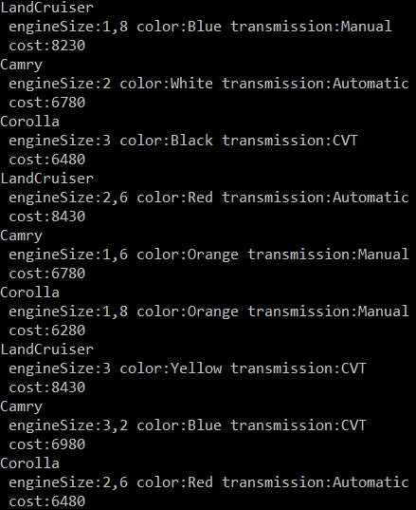

To sort cars need use method SortedComplectationOfCars() by passing collection **cars**. This method display only cost of complectation set without price of the model of car.

For sorting cars by price need use method SortedCarCost() by passing collection cars. This method display the price of the car taking into complete set and price of model.

To sort cars given price range need use GetComplectationOfPriceRange() method. This method accepts a collection **cars** and entering price range and display all cars in the price range.

To save data in the file need use method Serialize(), this method accept a collection **cars** and serialize on the directory which you need.